# CS 255 System Design Document Template

**Author: Jeba Singh Emmanuel**

## UML Diagrams

### UML Use Case Diagram

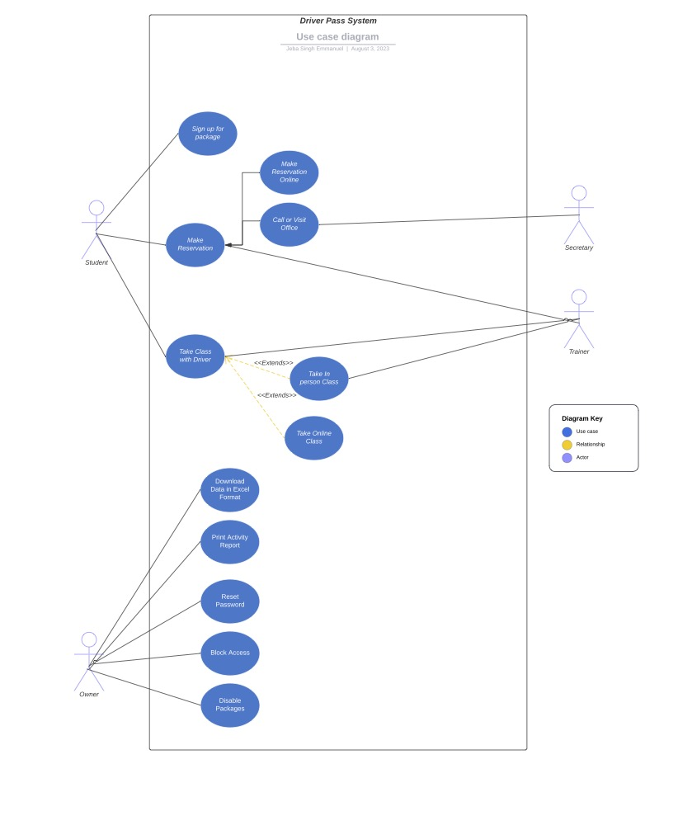

### UML Activity Diagrams

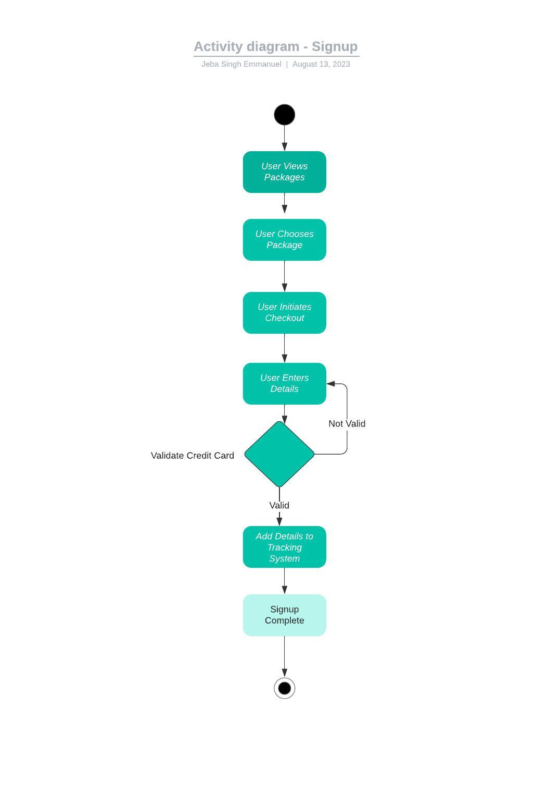

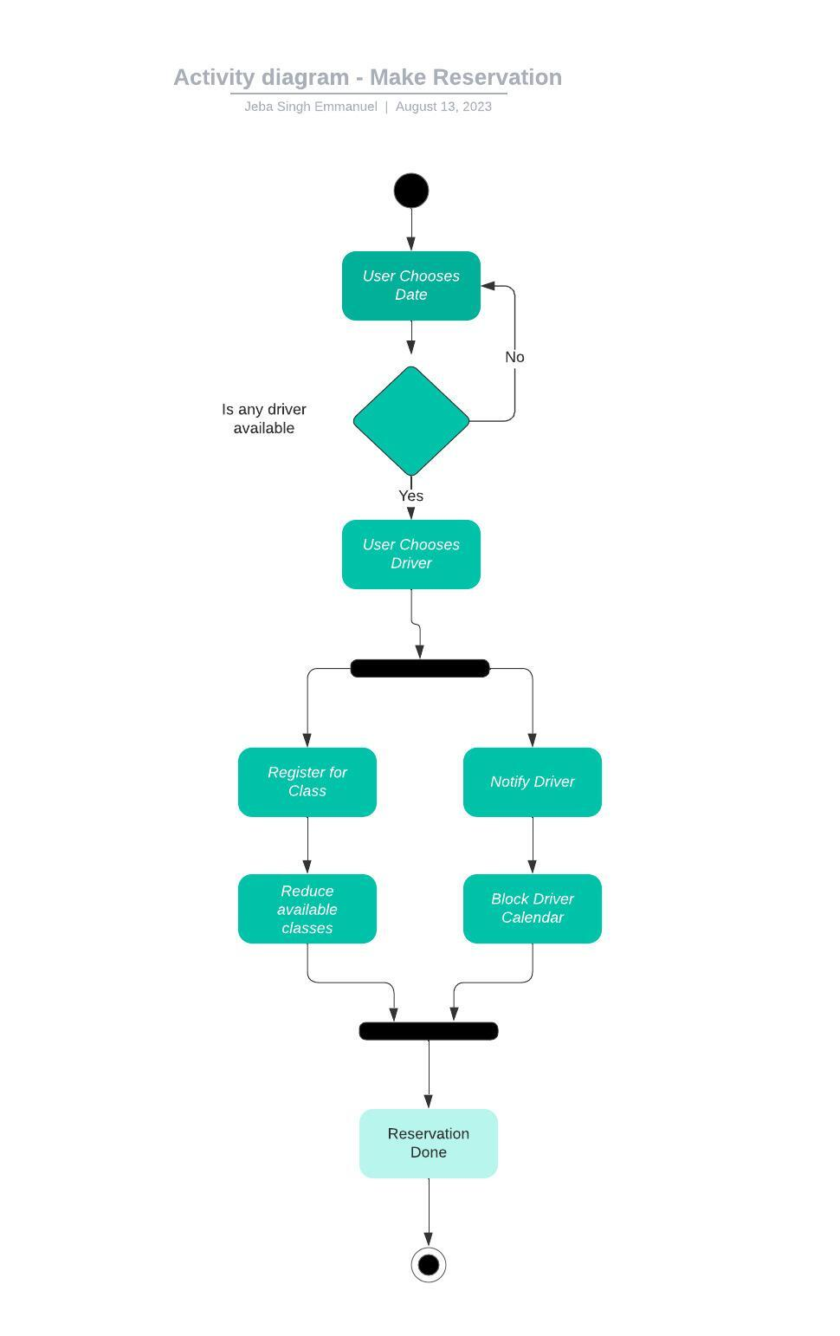

### UML Sequence Diagram

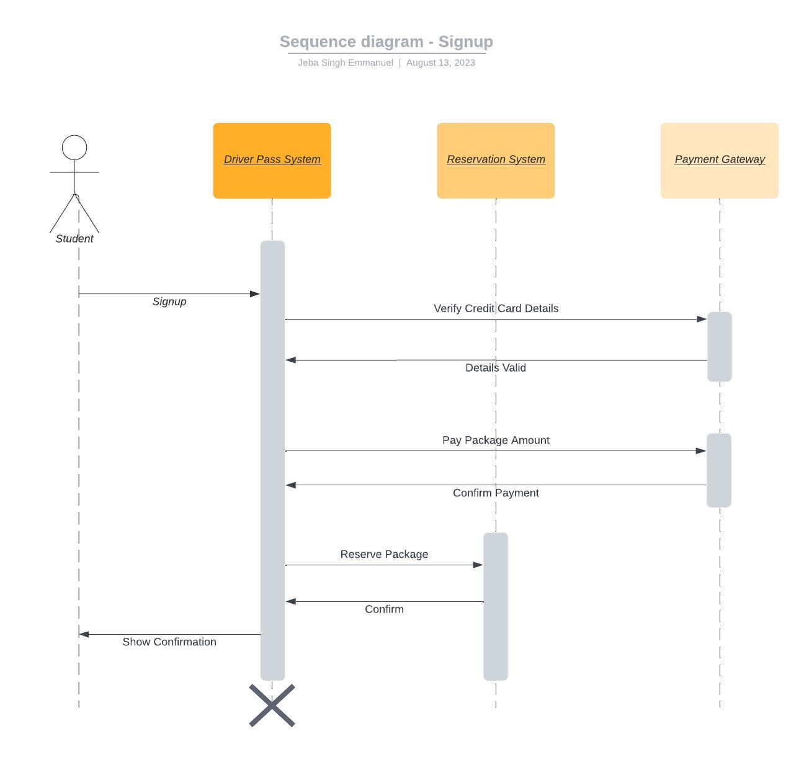

### UML Class Diagram

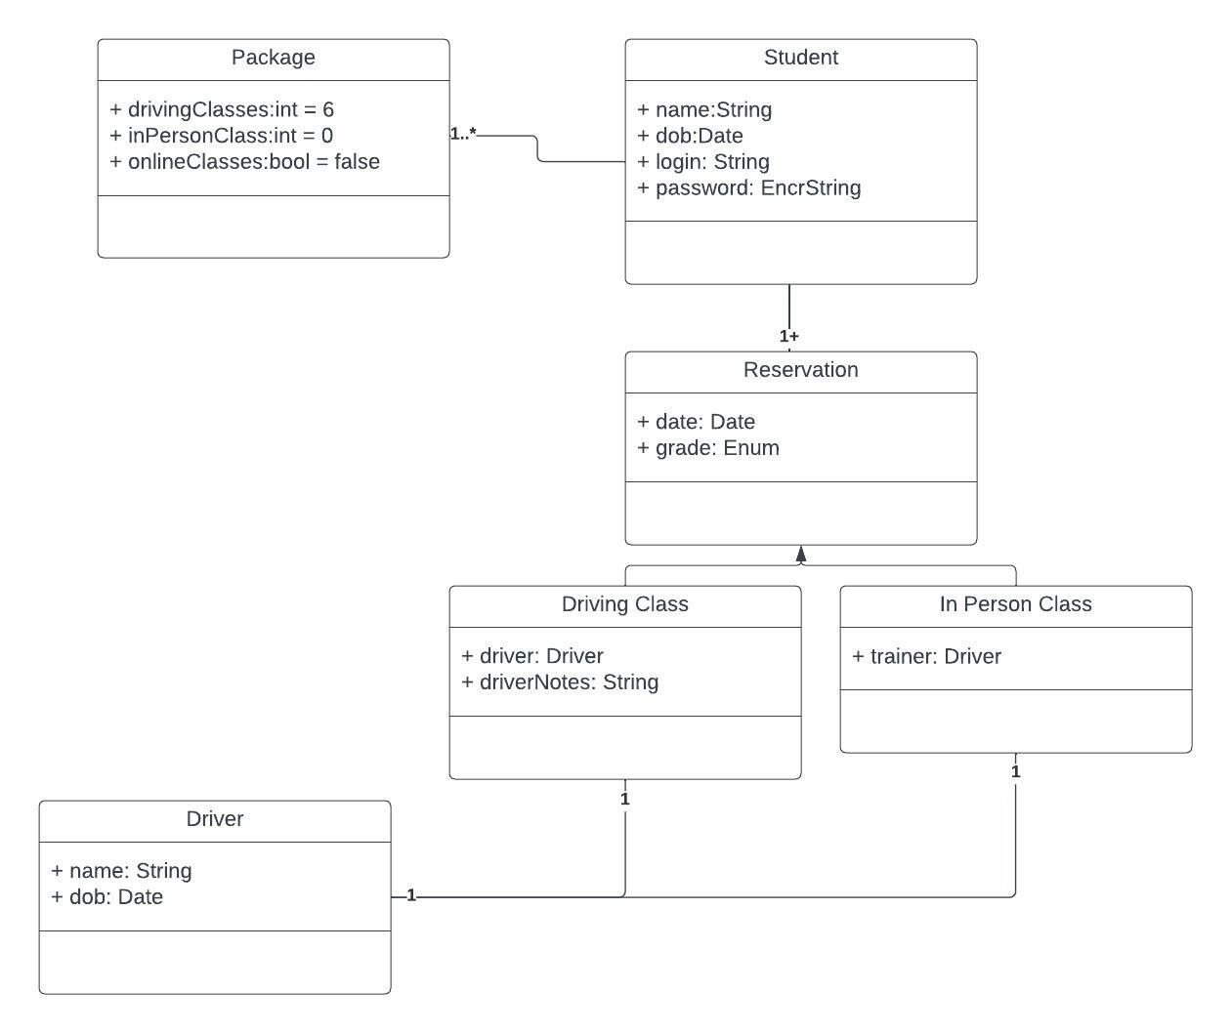

## Technical Requirements

Hardware

* Virtual Machines on the Cloud (potentially EC2 machines on AWS)
* Apple Macbooks for Owner, Staff to access Driverpass website
* IPads for Drivers to access driver management software and update notes

Software

* Backup software to back up code and databases from AWS to local backups
* Antivirus software to regularly scan website
* DB -> Excel software to allow owner to view overall records
* Software to monitor DMV updates and send email

Geographic information and other

* Mainly available in USA
* Ability to down some information to view offline